VFW Post 8337 drapes our charter for Life Member
George Lester “Mr.” Erickson November 10, 1923 – January 24, 2009
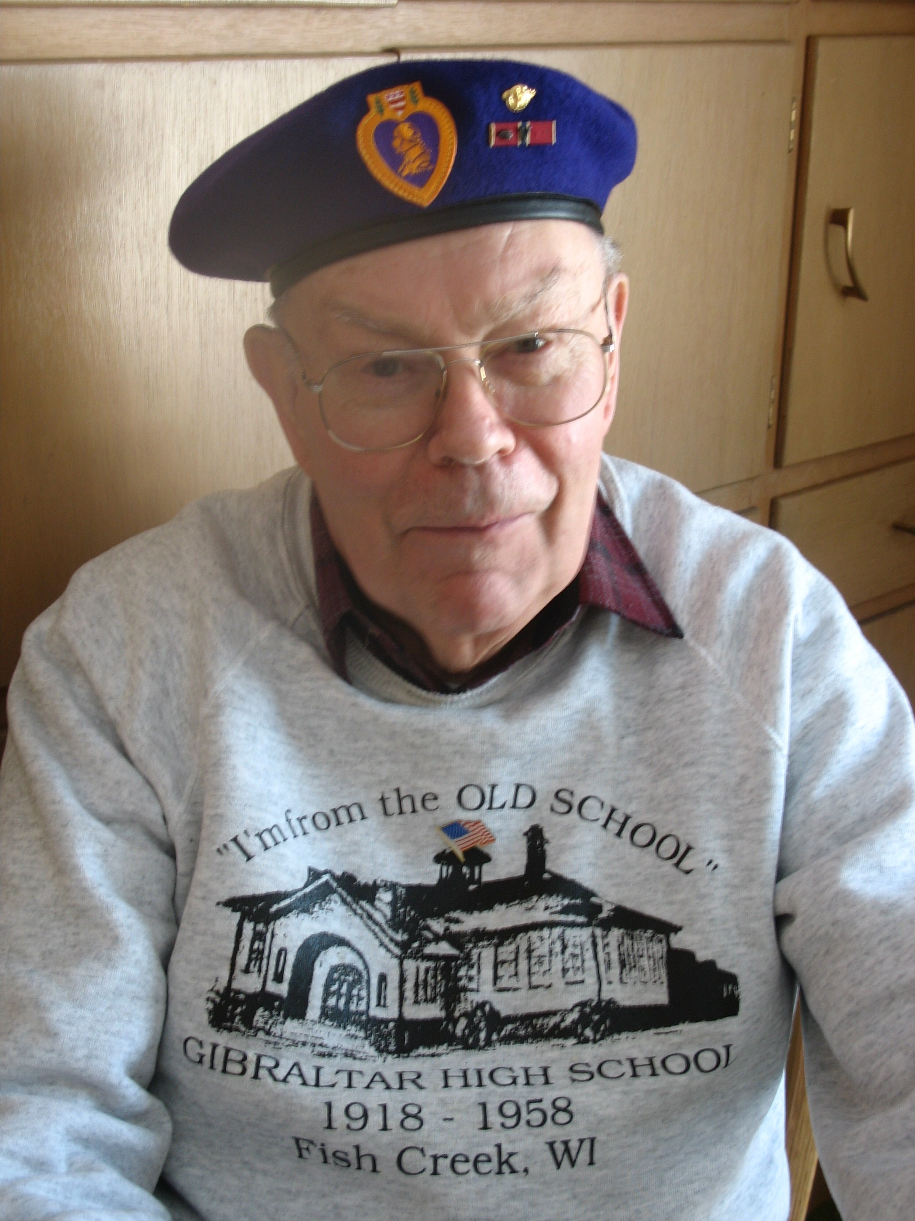
George was born at Sturgeon Bay to Frank Elmer and Eva (Evelyn Lewis) Erickson. He departed to his heavenly home on January 24, 2009. He spent his early years in Sister Bay, attended Wildwood, Gibraltar High and graduated with a Masters in Education from Northwestern University in Evanston, Illinois in 1949.
He married Annette Jane Ebbers on July 13, 1950. The Lord honored them with four wonderful children: William (Donna); James (Dorothy); Thomas (deceased 1994); and Beth (Thomas Willmann). In addition to his wife and children, he is survived by six grandchildren: Amy Joy, David, Michael, Alise Renee, Lauren Thomas, David Thomas, and Jacquelyn Cenfu; also he is survived by dear Tracy and honorary son-in-law Timothy Anderson, sister-in-law Beverly (DelMar Jaquish), special family friend Margaret Loving, and numerous other relatives and friends.
He was preceded in death by his parents, his sister Edna L. Erickson, and his beloved son Tom.
He served in the Army in WWII in the European Theater participating in the Battle of Rhineland, and with the Military Government from London to Berlin. He also took part in the occupation of Japan, and was later recalled to active duty for service during the Korean War. He later achieved the rank of Captain in the Army Reserve. During his military service he was awarded the Combat Infantry Man’s Badge, the Bronze Star medal for valor, and the Purple Heart.
George was a teacher and counselor serving schools in Madison, West Bend, Stoughton, and in Fish Creek where he was a Gibraltar teacher and counselor for thirty years, retiring in 1989. George had a love for his students and always thought of them as his “kids”, even when they were going on Social Security and Medicare.
George was a member of the Kiwanis Club, the ‘American Legion, Veterans of Foreign Wars, Military Order of the Purple Heart, the 102nd Infantry Division Association, Sister Bay Historical Society, Liberty Grove Historical Society, Phi Delta Kappa Educational Fraternity, the Scandia Auxiliary, FGBMFI, and numerous others.
George had a great love for his Savior, Jesus Christ - Israel’s Messiah and was part of church fellowships. First Baptist Church – Sister Bay where he came to know Jesus as his Savior, Moody Memorial Church – Chicago where he was baptized, First Baptist at West Bend, WI, and Community Church of Fish Creek where he had the privilege of serving the Lord for over thirty years, including the joy of the founding of Good Samaritan Society Scandia Village.
Rich Woldt – Commander VFW Post 8337
Military Honors:
An honor guard (35 strong) from VFW Post 8337, American Legion Post 527, AMVET Post 51, and the Marine Corp League conducted military honors to include Presentation of our flag, Presentation of Wisconsin Department of Veteran Affairs Commemorative Medallion, Presentation of Commemorative Bible, and eco-taps Post 8337 Jeffery Budzis and Marine Corp League’s Bucky “BUCKO” Honold.
Roll Call from VFW Post 8337 included:
1. Richard Woldt
2. Ronald Weber
3. Robert Tidball
4. Frank Stvan
5. Davis Sitte
6. Roy Sheahen
7. Gerald Polster
8. David Niedzwiecki
9. Russell LeClair
10. Don Johnson
11. Bruce Hanson
12. Leo Ducharme
13. Carl T. Carlson
14. Leland L. Burnett
15. Jeffrey Budzis

George shared a birthday with the Marine Corp. At one point he passed on a WWI purple heart to BUCKO who wore it at the memorial service.

